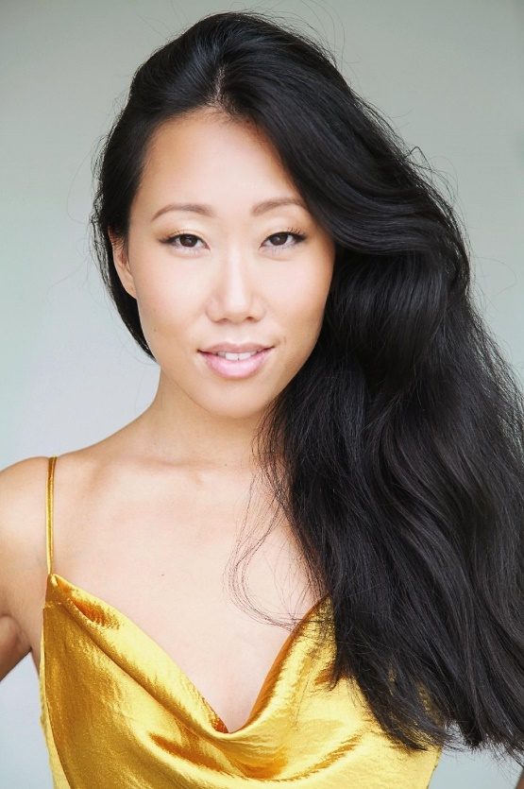
Playing age: 18-30
Height: 5.5
Vocal Range: C below middle C to top C

Training
Base 23, “Stockholm Musical Education” 2013-2015

Musical Theatre
Cabaret Gothenburg Opera House Ensemble Upcoming
King & I UK & International Tour U/S Tuptim 2019
Miss Saigon UK & International Tour U/S Gigi 2018-2019
Miss Saigon UK tour, Original cast Yvonne 2017-2018
We will rock you Royal Arena Teen queen and ensemble 2017
Snow White-The Musical Maxim Theatre U/S Snow White 2016
Wild Thing about love Metropol Palais Ensemble 2015
Spring Awakening Kulturhuset Stadsteatern Ensemble 2015
(Whilst Training)

TV, Commercial and Film
Film “State of Prey” Actress “Meifeng” 2020
Commercial “Sneakers and Stuff” Model 2019
Commercial “Gröna Lund” Actress 2019
Photo shoot “Atlas Copco” Model 2019
Film “The Pagan King” Speaker “Lauga” 2018
Commercial “Swedish idol” Actress 2017
Commercial “Preem” Actress 2017
Commercial “Laphroaig” Actress 2016
Photo shoot “IKEA” Model 2016
Commercial “SAS” Actress 2016
Photo shoot “Nikon” Model 2016
Film “Wallander” Actress “Nurse” 2015
TV- show “Sommarkrysset” Artist & dancer 2015
TV-gala “Queen Silvia’s Lead (musical) 2014
70’s birthday”

Instruments
Violin 12 years
Piano 6 years

